WIXAMS PARISH COUNCIL

Councillors, I hereby summon you to attend the meeting of WIXAMS PARISH COUNCIL on Tuesday, 17th January 2023 commencing at 7:45pm at the Munson Room, Lakeview Village Hall to consider the following items of business.
Robbin Brough, Clerk to the Council
10th January 2023

MEMBERS OF THE PUBLIC WELCOME!

AGENDA

1  2  3  4  5  6  7  8  9  10  11  12 | Apologies for Absence  Declarations of interest in items on the agenda  Public Open Session (If still required)  - Update from Bidwells on two upcoming planning applications for Town Centre schools in Wixams  - Other members of the public  During the Public Open Session: Members of the public should note that the council is only allowed to take decisions on topics that are publicised on the agenda; items not on the agenda can be carried forward for a response at a later date. Any questions not presented to the council far enough in advance of the meeting may be noted and responded to at a later time.  After the Public Open Session: Members of the public are asked to respect the fact that this is a meeting to conduct council business and interruptions during the remainder of the meeting are not permitted.  To confirm the minutes of the parish council meeting held on 20th December 2022  Clerk’s report on actions  BBC Highways:  - Arrange a meeting with BBC Highways to review the newly-implemented No Footway Parking restrictions and double yellow lines on Brooklands Ave and Bedford Road.  - Investigate whether the original planning application included two parking bays on Brooklands Ave which have not been included in the development of the road.  - Chase for an update on when the feasibility study will be completed by BBC Highways for potential new pedestrian crossings.  - Contact BBC Highways regarding traffic safety concerns at the Wilstead Industrial Estate Junction, Watson Road.  Other:  - Youth club: Clerk has been attending sessions with BBC Youth Services and the service provider (4YPUK) in relation to the provision of the youth club. Update to be provided by Clerk.  Correspondence (new items flagged for council attention):  - None requiring council attention.  To receive the Crime Statistics report  - Crime report issued to council prior to the meeting.  Councillors’ Reports including:  - Report from Borough Councillor Coombes (Wilshamstead)  - Report from Borough Councillor Tim Hill (Wixams Retirement Village)  - Planning Committee: Planning meeting  APPLICATION NO: 22/02767/REM Approval of Reserved Matters Application  PROPOSAL: All Reserved Matters except access, for strategic infrastructure works for the  installation of 4 substations pursuant to Outline permission 11/01380/M73.  LOCATION : Land At Village 3 And 4 Bedford Road Wixams Bedfordshire  APPLICATION NO: 22/02749/OUT Outline Application  PROPOSAL: Outline application for the demolition of existing dwelling and erection of one  replacement dwelling and eight new dwellings, including upgraded access.  Appearance and landscaping reserved with access, layout and scale being  considered  LOCATION : 175 Bedford Road Wilstead Bedford Bedfordshire MK45 3HU  - Update from Green Spaces Committee  - Update from Events Committee: No Grants Meeting  Defibrillator Training  To decide which day to host a defibrillator training session for Wixams residents.  King’s Coronation  To decide if the council would like to purchase decorations to commemorate the King’s Coronation on 6th May.  Budget and precept 2023/24  To set the budget and precept for 2023/24.  Finance  To approve payments and note balances.  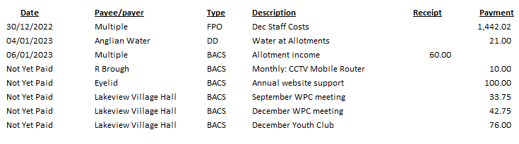  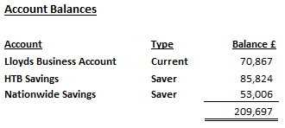  Business for future agendas (No actions can be taken on items not on the agenda)  Date of the next meeting: 21st February 2023 – Munson Room, Lakeview Village Hall.

